TITLE: - LEGACY IO

AIM: -
To display a text by writing values to port 60h/64h
ALGORITHM: -
· Initialize the data segment.
· Display the start message.
· Read the Keyboard Controller status from port 64h and loop until the input buffer is empty (Bit 1 is 0).
· Write the command D2h (Write Output Buffer) to the Keyboard Controller command port 64h.
· Read the status from port 64h again and wait until the input buffer is empty.
· Write the target data byte ('A') to the Keyboard Controller data port 60h.
· Display the predefined text string on the screen using DOS interrupts.
· Display the success message.
· Terminate program execution.
PROGRAM:-
TITLE KBCW.ASM -- Display Text by Writing to Port 60h/64h

;//***********************************************************************
;//* *
;//* Copyright (c) 1985-2025, American Megatrends International LLC. *
;//* *
;//* All rights reserved. Subject to AMI licensing agreement. *
;//* *
;//***********************************************************************

;<AMI_FHDR_START>
;
; Header:
; Author: Muthuganesh S
; Description:
; Program to send commands/data through Keyboard Controller
; ports 60h and 64h and display text on screen.
;
;<AMI_FHDR_END>

.model small
.386
.stack 100h

;----------------------------------------------------------------------------
; DATA SEGMENT
;----------------------------------------------------------------------------
data segment

msg1 db 13,10,"Writing Data to Keyboard Controller Ports 64h and 60h",13,10,'$'
msg2 db 13,10,"Text Displayed Successfully",13,10,'$'

text db 'HELLO BIOS','$'

data ends
;----------------------------------------------------------------------------

;----------------------------------------------------------------------------
; CODE SEGMENT
;----------------------------------------------------------------------------
code segment
assume cs:code, ds:data

start:

mov ax,data
mov ds,ax

;--------------------------------------------------
; Display Start Message
;--------------------------------------------------
mov dx,offset msg1
mov ah,09h
int 21h

;--------------------------------------------------
; Wait Until Keyboard Controller Input Buffer Empty
; Status Port = 64h
; Bit1 = Input Buffer Status
;--------------------------------------------------
wait_input_empty:

in al,64h
test al,02h
jnz wait_input_empty

;--------------------------------------------------
; Send Command to Keyboard Controller
; Command D2h:
; Write Output Buffer
;--------------------------------------------------
mov al,0D2h
out 64h,al

;--------------------------------------------------
; Wait Again
;--------------------------------------------------
wait_input_empty2:

in al,64h
test al,02h
jnz wait_input_empty2

;--------------------------------------------------
; Send Data Byte to Port 60h
;--------------------------------------------------
mov al,'A'
out 60h,al

;--------------------------------------------------
; Display Text Normally
;--------------------------------------------------
mov dx,offset text
mov ah,09h
int 21h

;--------------------------------------------------
; Success Message
;--------------------------------------------------
mov dx,offset msg2
mov ah,09h
int 21h

;--------------------------------------------------
; Exit Program
;--------------------------------------------------
mov ah,4Ch
int 21h

code ends
end start
OUTPUT: -
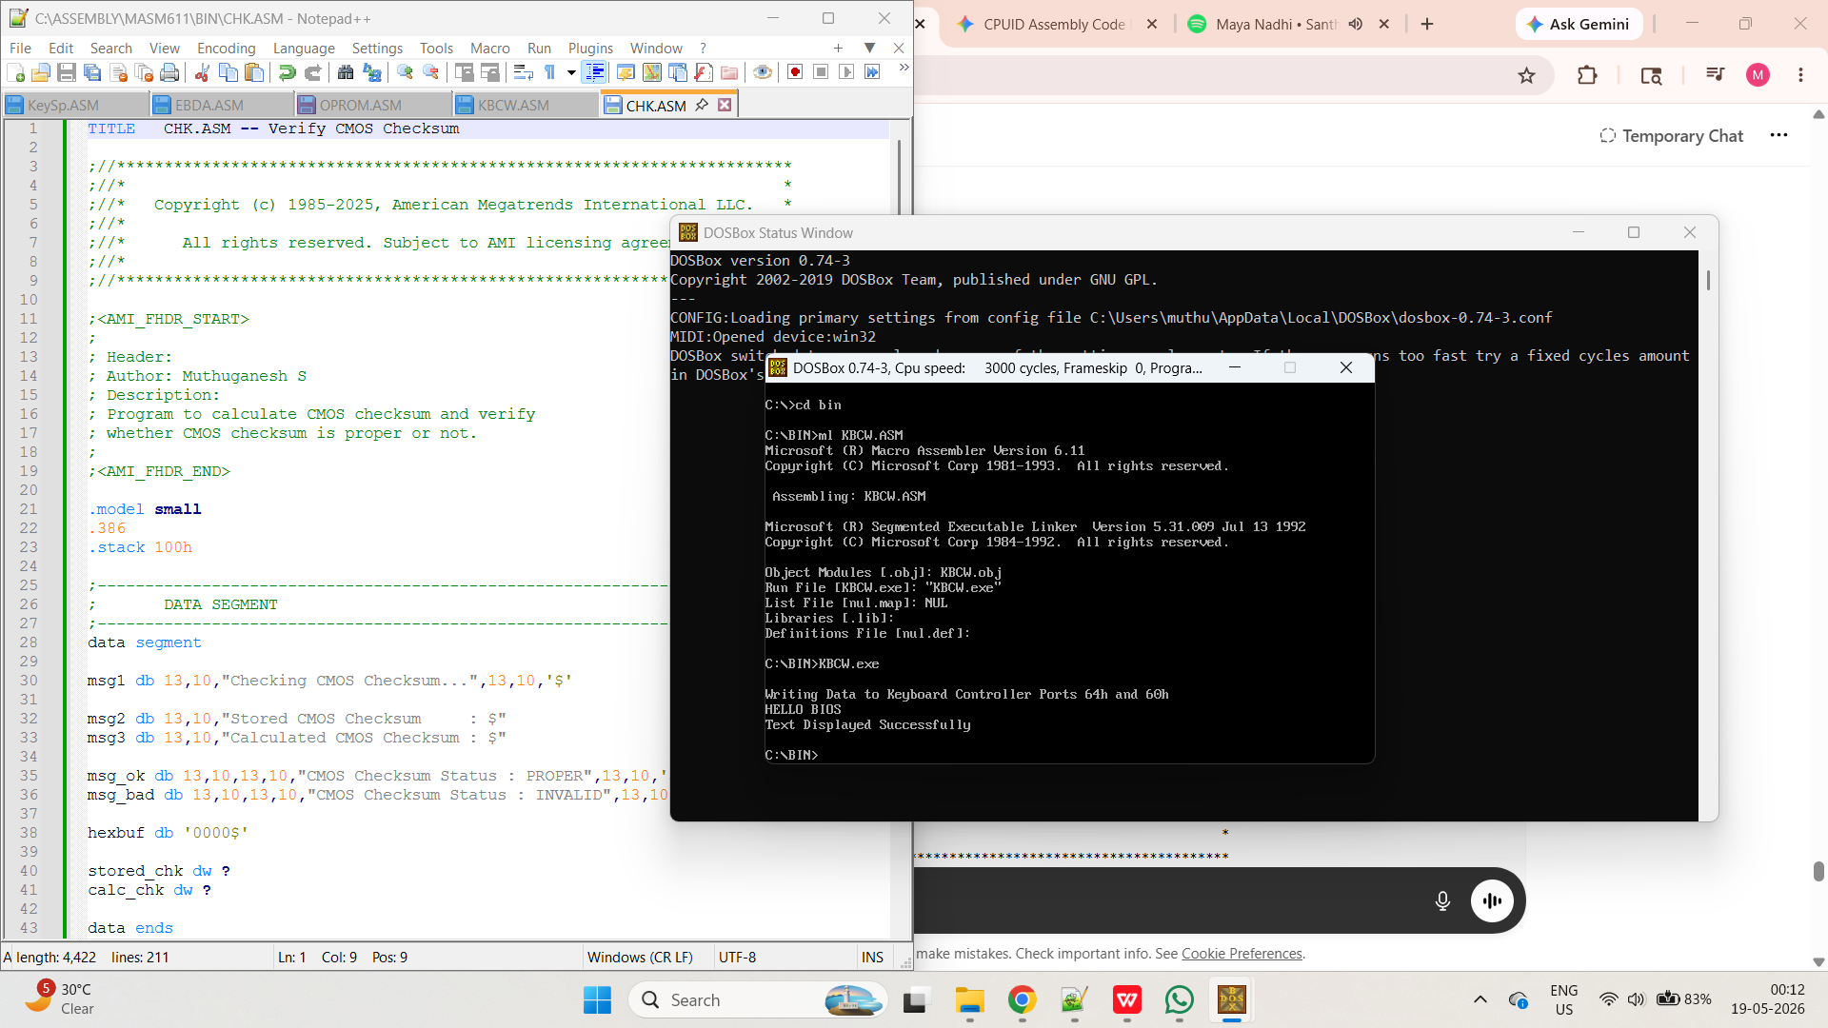

AIM: -
To check and display whether the CMOS checksum is proper or not.
ALGORITHM: -
· Initialize the data segment.
· Display the start message.
· Initialize a checksum accumulator (register BX) to zero.
· Loop through CMOS memory addresses from 10h to 2Dh.
· For each address, write the address to CMOS index port 70h, read the data byte from data port 71h, and add it to the accumulator.
· Save the final accumulated value as the calculated checksum.
· Read the stored checksum high byte from CMOS address 2Eh and the low byte from address 2Fh (using ports 70h and 71h).
· Combine both bytes to form the stored 16-bit checksum.
· Display the stored CMOS checksum in hexadecimal format.
· Display the calculated CMOS checksum in hexadecimal format.
· Compare the calculated checksum with the stored checksum.
· If the checksums match, display the "PROPER" validation message.
· If the checksums do not match, display the "INVALID" validation message.
· Terminate program execution.
PROGRAM:-
TITLE CHK.ASM -- Verify CMOS Checksum

;//***********************************************************************
;//* *
;//* Copyright (c) 1985-2025, American Megatrends International LLC. *
;//* *
;//* All rights reserved. Subject to AMI licensing agreement. *
;//* *
;//***********************************************************************

;<AMI_FHDR_START>
;
; Header:
; Author: Muthuganesh S
; Description:
; Program to calculate CMOS checksum and verify
; whether CMOS checksum is proper or not.
;
;<AMI_FHDR_END>

.model small
.386
.stack 100h

;----------------------------------------------------------------------------
; DATA SEGMENT
;----------------------------------------------------------------------------
data segment
msg1 db 13,10,"Checking CMOS Checksum...",13,10,'$'
msg2 db 13,10,"Stored CMOS Checksum : $"
msg3 db 13,10,"Calculated CMOS Checksum : $"

msg_ok db 13,10,13,10,"CMOS Checksum Status : PROPER",13,10,'$'
msg_bad db 13,10,13,10,"CMOS Checksum Status : INVALID",13,10,'$'

hexbuf db '0000$'

stored_chk dw ?
calc_chk dw ?

data ends
;----------------------------------------------------------------------------

;----------------------------------------------------------------------------
; CODE SEGMENT
;----------------------------------------------------------------------------
code segment
assume cs:code, ds:data

start:

mov ax,data
mov ds,ax

;--------------------------------------------------
; Display Start Message
;--------------------------------------------------
mov dx,offset msg1
mov ah,09h
int 21h

;--------------------------------------------------
; Calculate CMOS Checksum
;
; Standard AT CMOS checksum area:
; 10h to 2Dh
;
; Stored checksum:
; 2Eh = High Byte
; 2Fh = Low Byte
;--------------------------------------------------
xor bx,bx
mov si,10h
checksum_loop:

mov al,si
out 70h,al

in al,71h
xor ah,ah
add bx,ax
inc si
cmp si,2Eh
jne checksum_loop

mov calc_chk,bx

;--------------------------------------------------
; Read Stored CMOS Checksum
;--------------------------------------------------
mov al,2Eh
out 70h,al
in al,71h

mov ah,al

mov al,2Fh
out 70h,al
in al,71h

mov stored_chk,ax

;--------------------------------------------------
; Display Stored Checksum
;--------------------------------------------------
mov dx,offset msg2
mov ah,09h
int 21h

mov ax,stored_chk
call PrintHexWord

;--------------------------------------------------
; Display Calculated Checksum
;--------------------------------------------------
mov dx,offset msg3
mov ah,09h
int 21h

mov ax,calc_chk
call PrintHexWord

;--------------------------------------------------
; Compare Checksums
;--------------------------------------------------
mov ax,stored_chk
cmp ax,calc_chk
jne checksum_invalid

checksum_valid:

mov dx,offset msg_ok
mov ah,09h
int 21h

jmp exit_program

checksum_invalid:
mov dx,offset msg_bad
mov ah,09h
int 21h
exit_program:
;--------------------------------------------------
; Exit Program
;--------------------------------------------------
mov ah,4Ch
int 21h
;----------------------------------------------------------------------------
; PrintHexWord Procedure
;----------------------------------------------------------------------------
PrintHexWord proc

push ax
push bx
push cx
push dx
push si

mov si,offset hexbuf
mov cx,4

hex_loop:
rol ax,4
mov bl,al
and bl,0Fh
cmp bl,9
jbe digit

add bl,7

digit:

add bl,'0'

mov [si],bl
inc si

loop hex_loop

mov dx,offset hexbuf
mov ah,09h
int 21h

pop si
pop dx
pop cx
pop bx
pop ax
ret
PrintHexWord endp

code ends
end start
OUTPUT: -
